General tips for the Task below.
Task Title
Jenkins Challenge-01
Objective
The objective of this challenge is to perform Jenkins pipeline build with experience gained from last 4 video tasks posted in Slack and worked on various Jenkins tasks earlier.
Prerequisites
List all requirements before starting:
- AWS-Ec2
- Git
- GitHub
- Jenkins
- Sonarqube
- Sonar-scanner
- Apache-Maven
- Nexus Artifacts
- Slack Notification
- Tomcat Deployment
Issues Faced: Briefly mention issues and how you fixed them. Posted below in the last.
Conclusion
Conclusion has been provided for every task at the end.

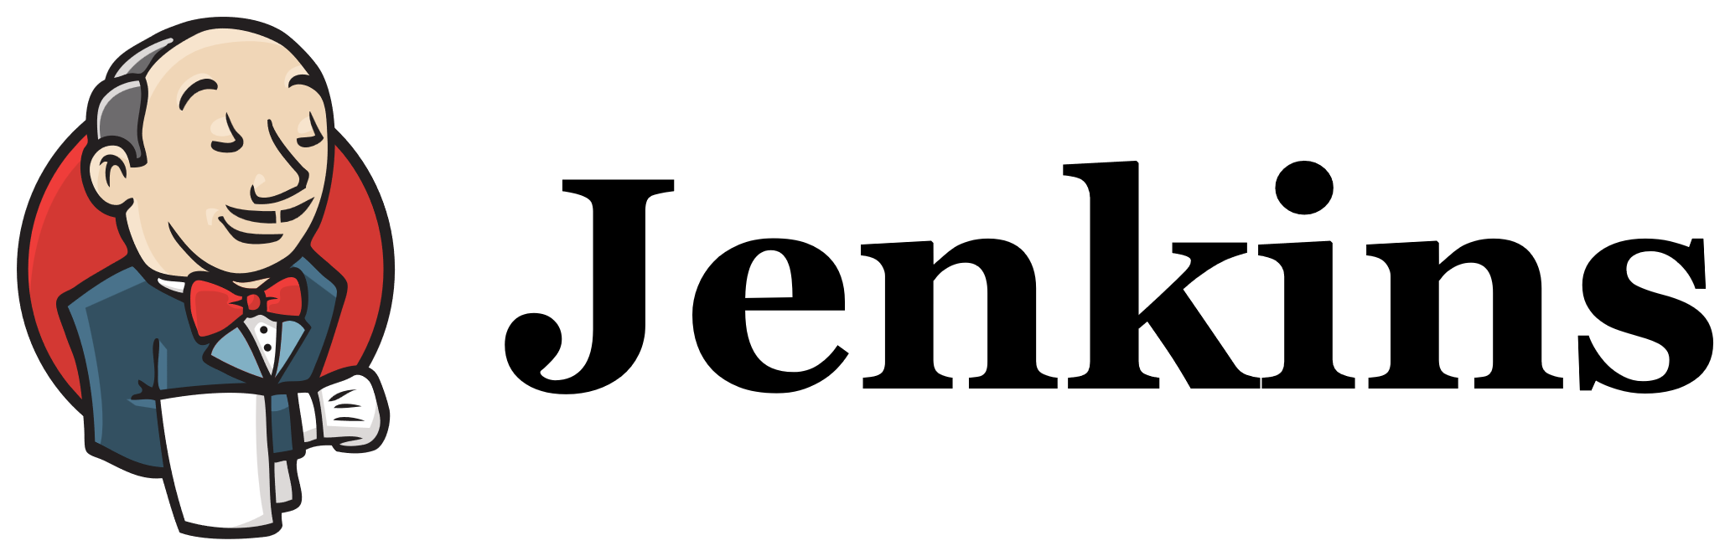
Jenkins Challenge-01

What is Jenkins Pipeline used for?
1. Continuous Integration (CI)
Automatically:
- Pull code from Git
- Build the application
- Run unit tests
- Perform code quality checks (SonarQube)
2. Continuous Delivery/Deployment (CD)
Automatically:
- Package the app
- Upload artifacts to Nexus/Artifactory
- Deploy to servers (Dev/Test/Prod)

Typical Pipeline flow-
Code Push → Build → Test → Code Scan → Package → Deploy → Notify

Why use Jenkins Pipeline?
✅ Automation
No manual work. Everything runs automatically.
✅ Repeatable
Same process every time → no human errors.
✅ Version Controlled
Pipeline is written as code (Jenkinsfile) and stored in Git.
✅ Faster Delivery
Releases become quicker and safer.
✅ Better Visibility
You can see each stage: build, test, deploy, etc.

Example Use Case
When a developer pushes code:
- Jenkins pulls code
- Builds it
- Runs tests
- Runs SonarQube scan
- Deploys to server
- Sends Slack/email notification
All automatically.

Declarative Pipeline
🔹 What it is:
A simpler, structured, and opinionated way to write pipelines.
🔹 Syntax style:
Follows a fixed structure with predefined blocks like pipeline, agent, stages, steps.
🔹 Pros:
✅ Easy to learn
✅ Clean and readable
✅ Less error-prone
✅ Built-in features (post, environment, tools)
✅ Best for standard CI/CD
🔹 Cons:
❌ Less flexible
❌ Not suitable for very complex logic

Scripted Pipeline
🔹 What it is:
A fully programmable pipeline written using Groovy.
🔹 Syntax style:
Free-form Groovy code with Jenkins steps.
🔹 Pros:
✅ Very flexible
✅ Supports complex logic
✅ Loops, conditions, custom functions
✅ Good for advanced workflows
🔹 Cons:
❌ Harder to read
❌ More chances of errors
❌ Not beginner-friendly
❌ No fixed structure

Key Differences
Feature | Declarative | Scripted
Syntax | Structured | Free-form
Learning Curve | Easy | Hard
Flexibility | Limited | High
Readability | High | Medium
Error Handling | Built-in | Manual
Best For | Standard CI/CD | Complex logic
Groovy Knowledge | Minimal | Required

What is Groovy?
Groovy is:
✅ A JVM-based scripting language
✅ Built on top of Java
✅ Simple, flexible, and powerful
✅ Supports loops, conditions, functions, classes
Jenkins uses Groovy because it can easily control logic, flow, and decisions.
Why Groovy is used in Scripted Pipeline?
Because Scripted Pipeline is not structured like Declarative. It behaves like a real program.
So, you can write logic like:
- If-else
- Loops
- Variables
- Functions
- Try-catch
- Dynamic behavior

Example: Groovy in Scripted Pipeline
Using variables:
node {
def app = "MyApp"
echo "Building ${app}"
}

Using conditions:
node {
if (env.BRANCH_NAME == 'main') {
echo "Deploying to production"
} else {
echo "Deploying to dev"
}
}

Using loops:

node {
for (int i = 1; i <= 3; i++) {
echo "Running test ${i}"
}
}

Using functions:

def buildApp() {
echo "Building application..."
}
node {
buildApp()
}
Groovy in Scripted Pipeline = Brain of the pipeline
It allows Jenkins to:
✔ Make decisions
✔ Run dynamic steps
✔ Handle complex workflows
✔ Customize behaviour

Use the below code and implement our CICD stages.
- Source Code: https://github.com/betawins/hiring-app.git
  - Repository contains the application code for the hiring app.

Task 1- Create one Declarative pipeline job

Objective:
To automate the build, test, and deploy process of a Java application using Maven, ensuring code quality with SonarQube and deploying Nexus artifacts to a staging environment.

Prerequisites:
1. Jenkins Setup
- Jenkins server installed and running.
- Required plugins installed:
  - Pipeline plugin (core requirement).
  - Git plugin (for source code checkout).
  - Maven plugin (if building Java projects).
  - SonarQube plugin (for code quality checks).
  - Credentials plugin (for secure access to Git.).
2. Source Code Repository
- Application code stored in GitHub
- A Jenkinsfile created in the repo (written in Declarative syntax).
- Branch strategy defined (e.g., main for production, develop for testing).
3. Build Tools
- Build system installed on Jenkins agent:
Maven for Java.
- Dependencies defined in pom.xml.

4. Credentials & Access
- Jenkins configured with:
  - Git credentials (only a private repo)
  - Artifact repo credentials (Nexus/Artifactory).
  - Deployment credentials (Tomcat Credentials)
5. Environment Setup
- Network access to Git repo, artifact repo, and deployment targets.
- Proper workspace cleanup policy to avoid conflicts.
6. Notification Tools (Optional but Recommended)
- Notification channels (Slack) integrated with Jenkins.

Note:
- We left all servers running overnight to perform this challenge
- If the instances are stopped, we should make sure to update all the new IPs in Jenkins GUI and Jenkins server.
- Manage Jenkins Credentials Update the Sonarqube token
- Manage Jenkins System Update new Jenkins URL
- Manage Jenkins System Update Sonarqube URL with new token created in Sonarqube GUI
- Jenkins server vi sonar-scanner. properties update sonarqube server new IP

Step by step Implementation:
Step 1: Launch Jenkins server
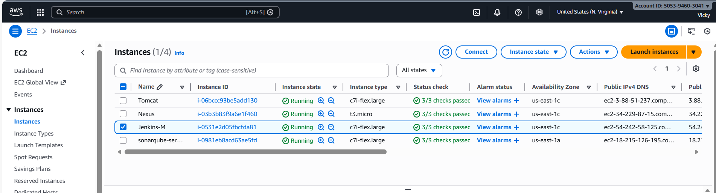

- Verify if Jenkins is up and running using command- systemctl status Jenkins
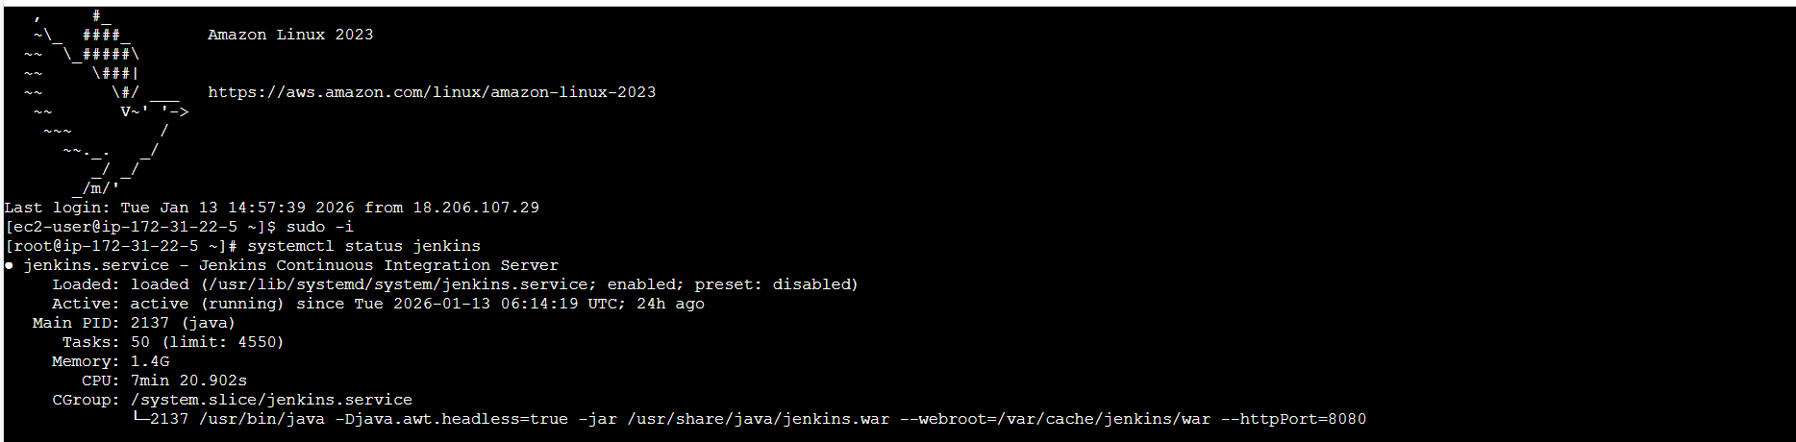
- Using Jenkins IP and port 8080, login to Jenkins from browser.
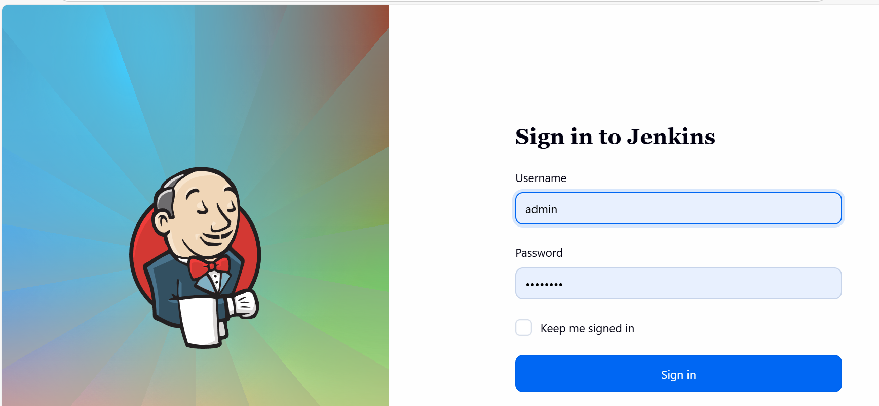

- Redirected to Dashboard after logging in.
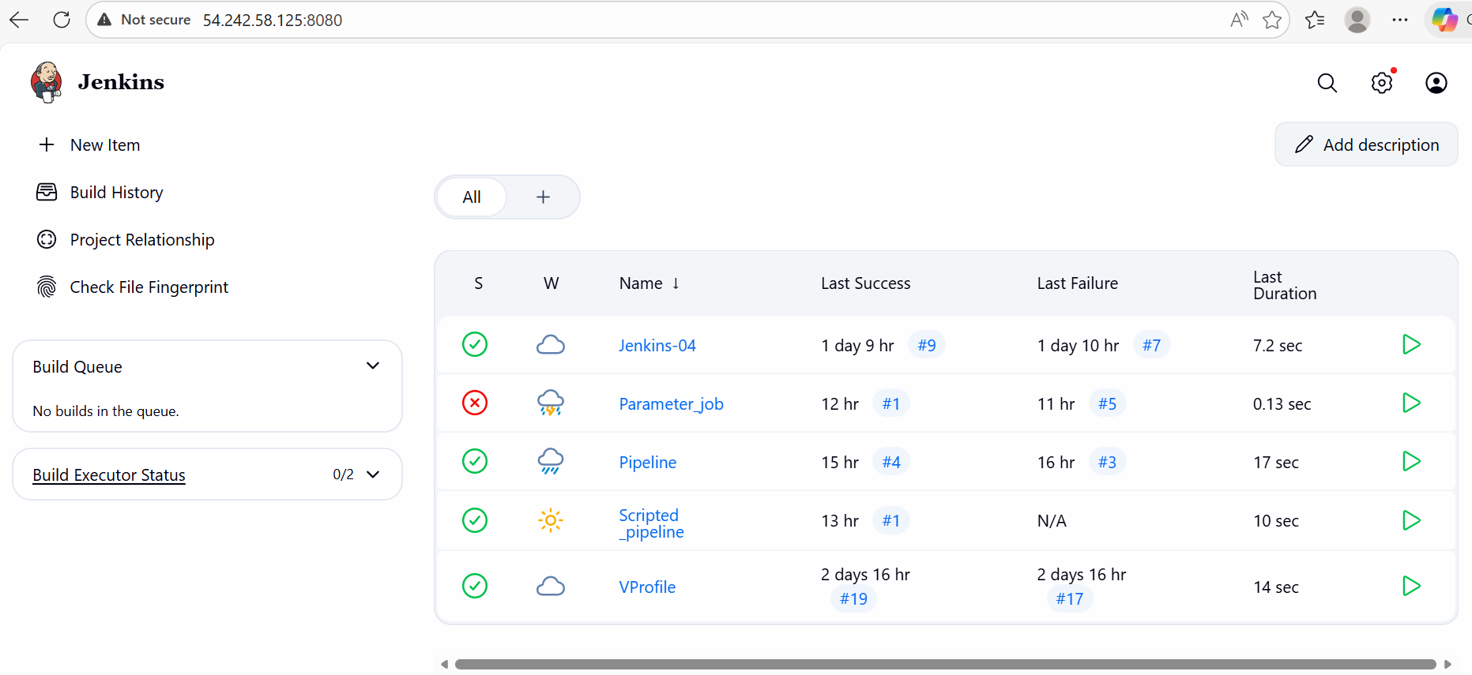

Step 2: Connect to Sonarqube server and verify if Sonarqube is up and running using docker method.
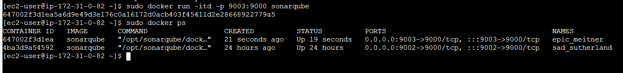
sqa_76bc92b97596da332910f0481a409fb233b8e6e3
- Unfortunately, my Sonarqube GUI wasn’t opening and my server crashed, so we had to stop the instance and restarted.
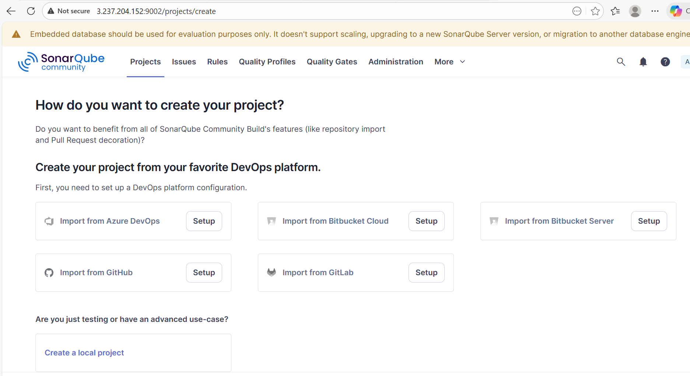

Step 3: Let’s launch Nexus server.
Start the service using command- ./nexus start

Cd /opt/
Cd nexus-3.87.1-01/
Cd /bin/
./nexus start
sudo ss -tulnp | grep 8081
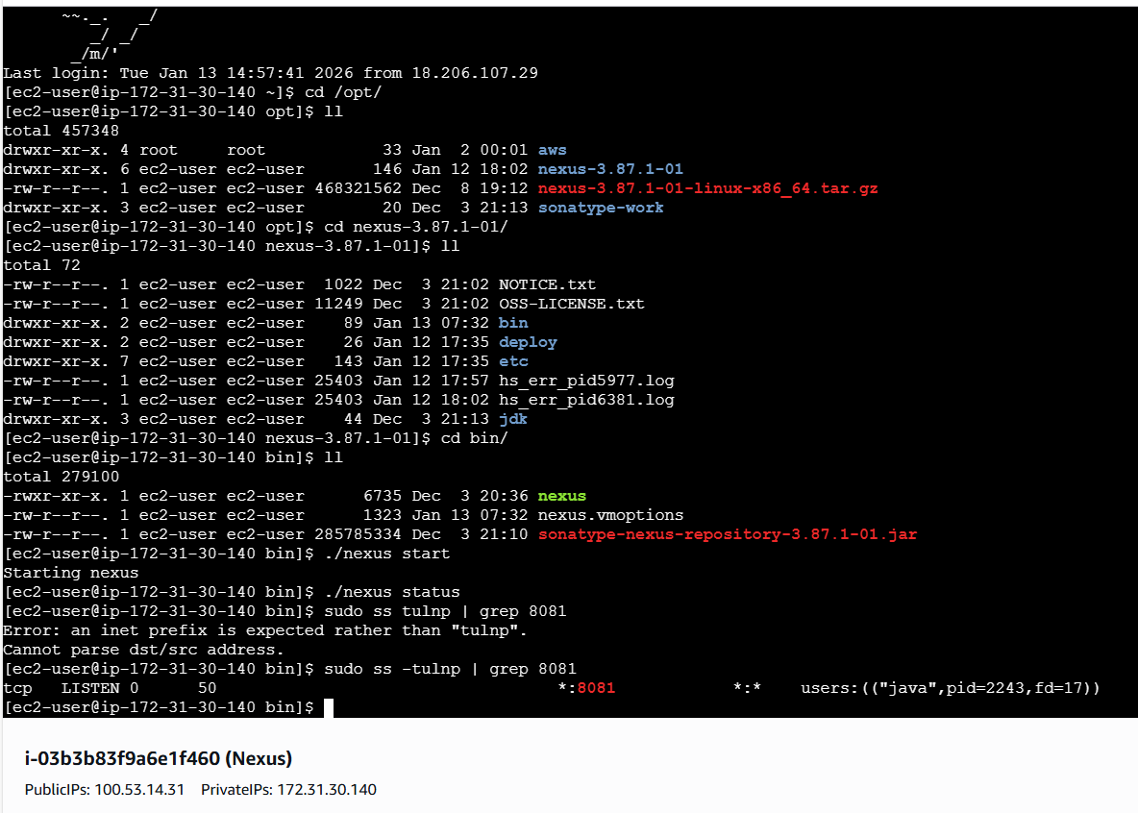

- Let’s verify in the browser with IP and port number to access the Nexus GUI
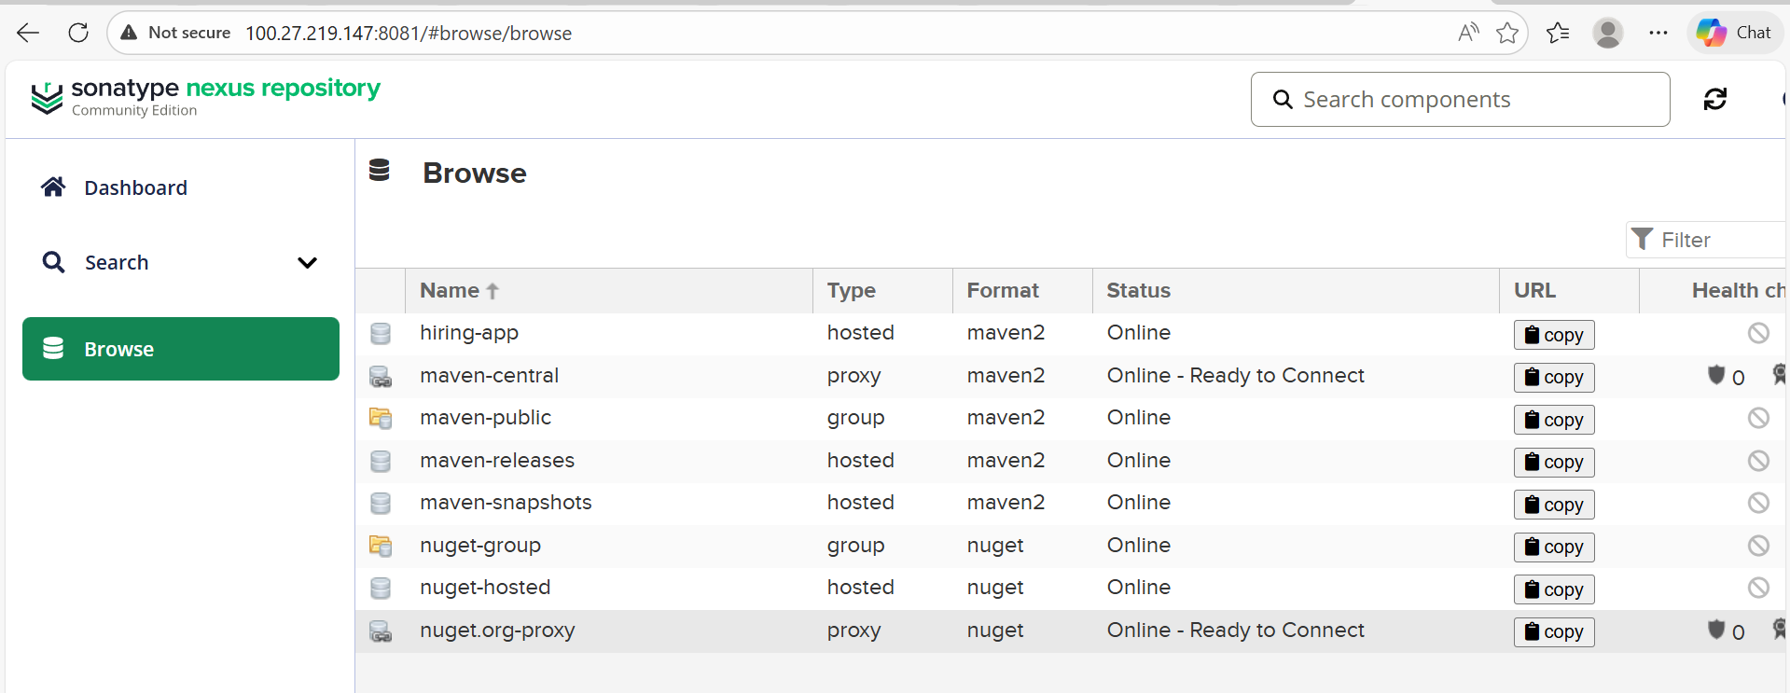

- We have already created a repository name- hiring-app, so we will be storing the artifacts in the same repo.
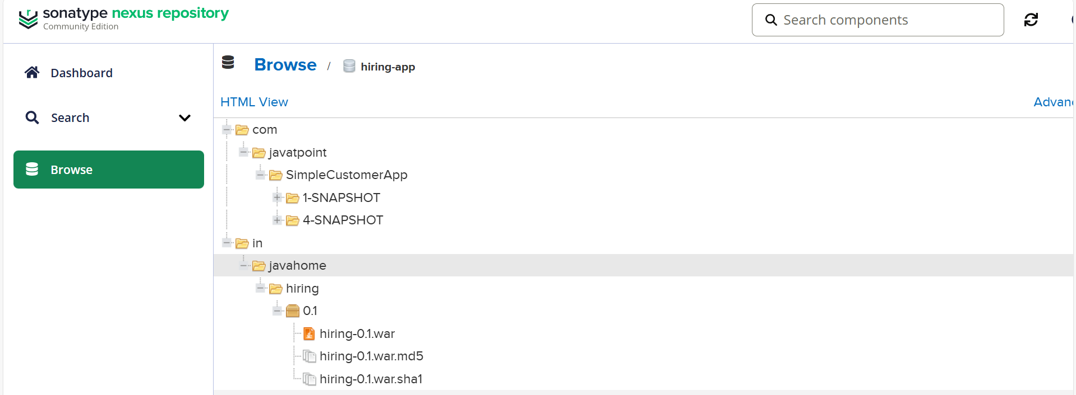

Step 4: Last stage is to launch Tomcat server.
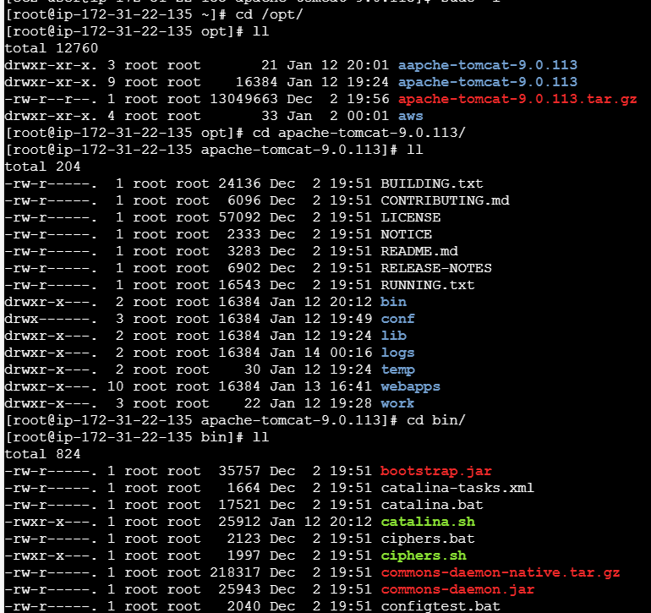
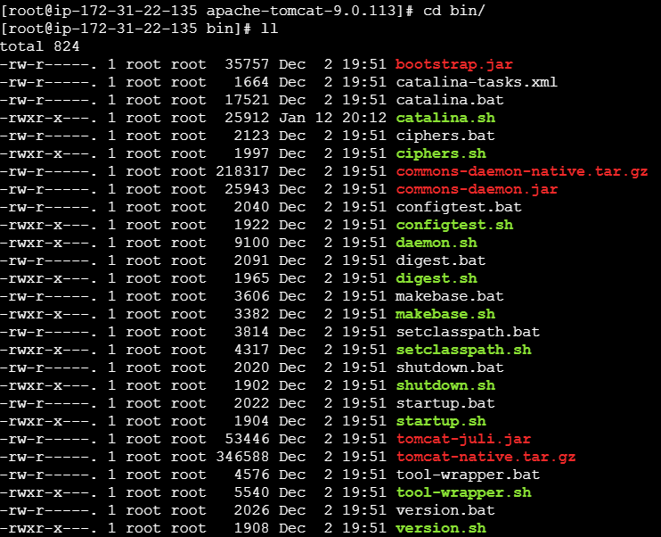
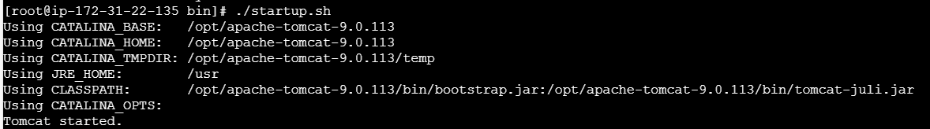

- Let’s verify in the browser, if Tomcat is up and running.
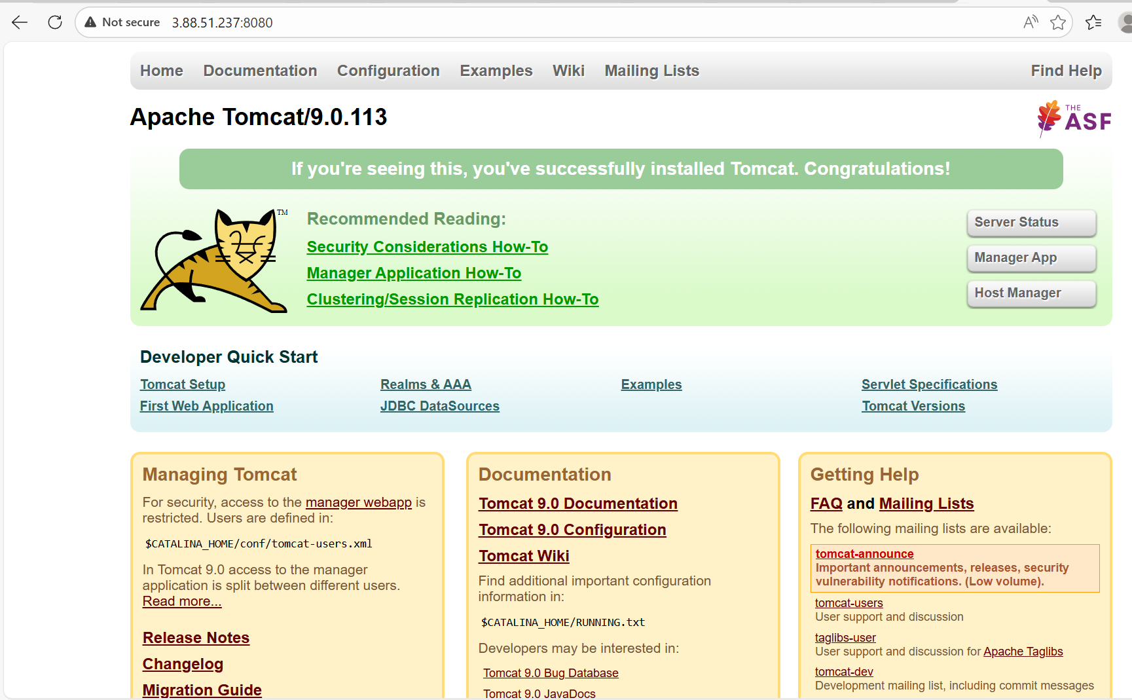

Step 5: Navigate to Jenkins GUI and create a job – Declarative_pipeline
- Style- Pipeline
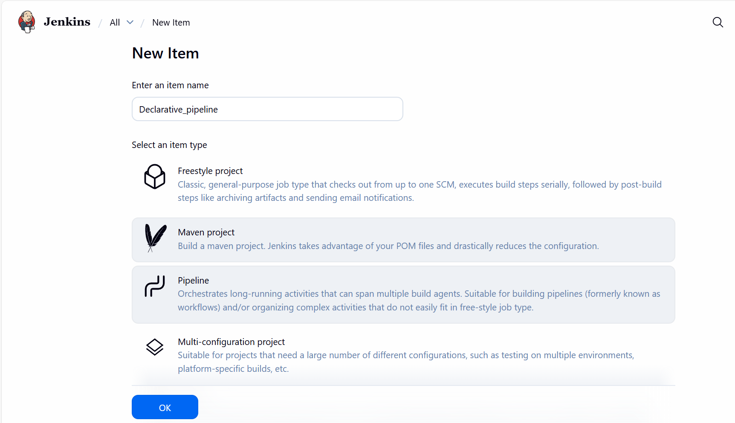

- Pipeline updated in the Script section and build for execution.
- Success.
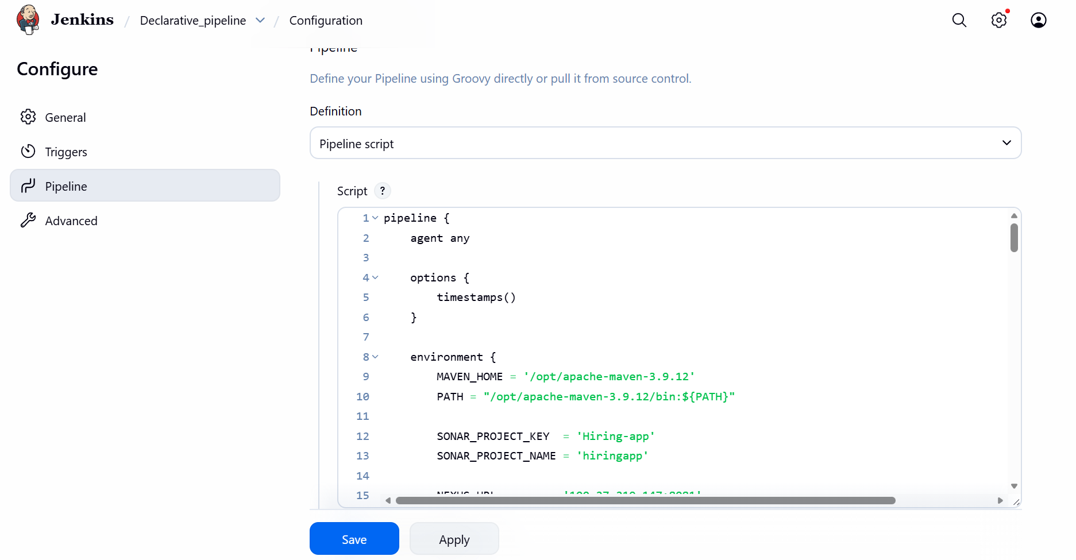
- Success, pipeline built successfully.
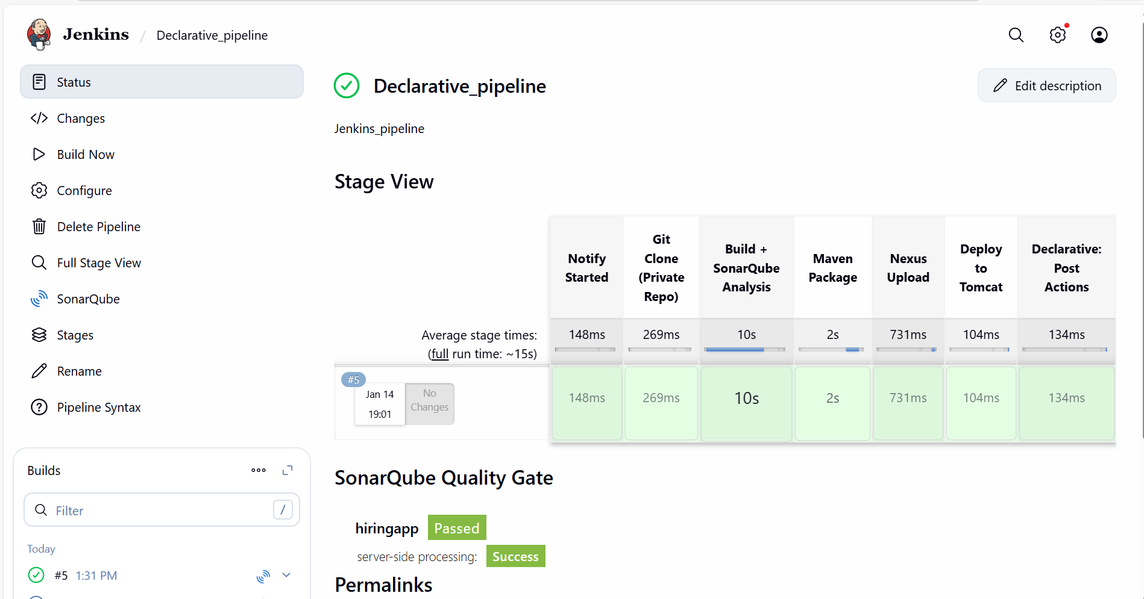

- Console output attached.
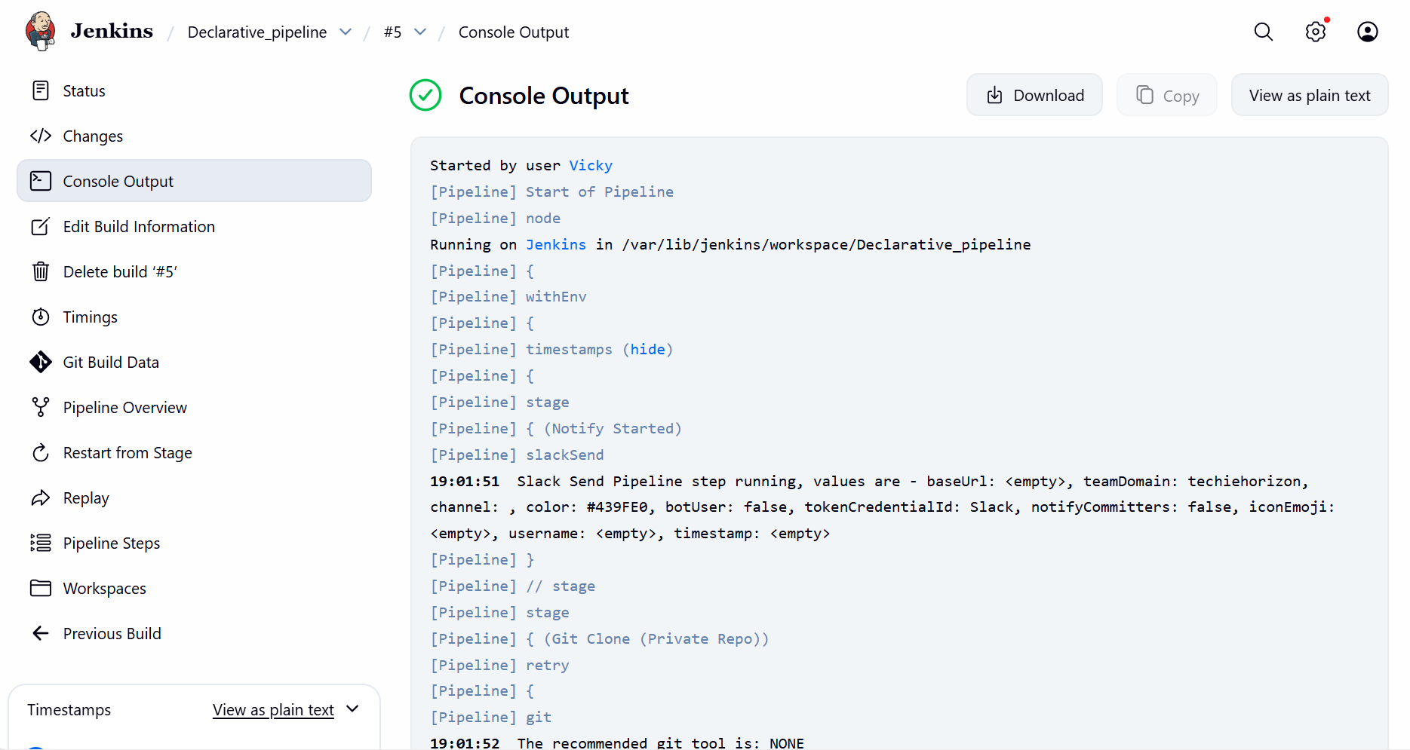

Step 6: Lets verify if the package is deployed to Tomcat.
Success- Yes, our package is deployed to Tomcat
Package- hiring.war – in Tomcat server (cd /opt/apache-tomcat/webapps)

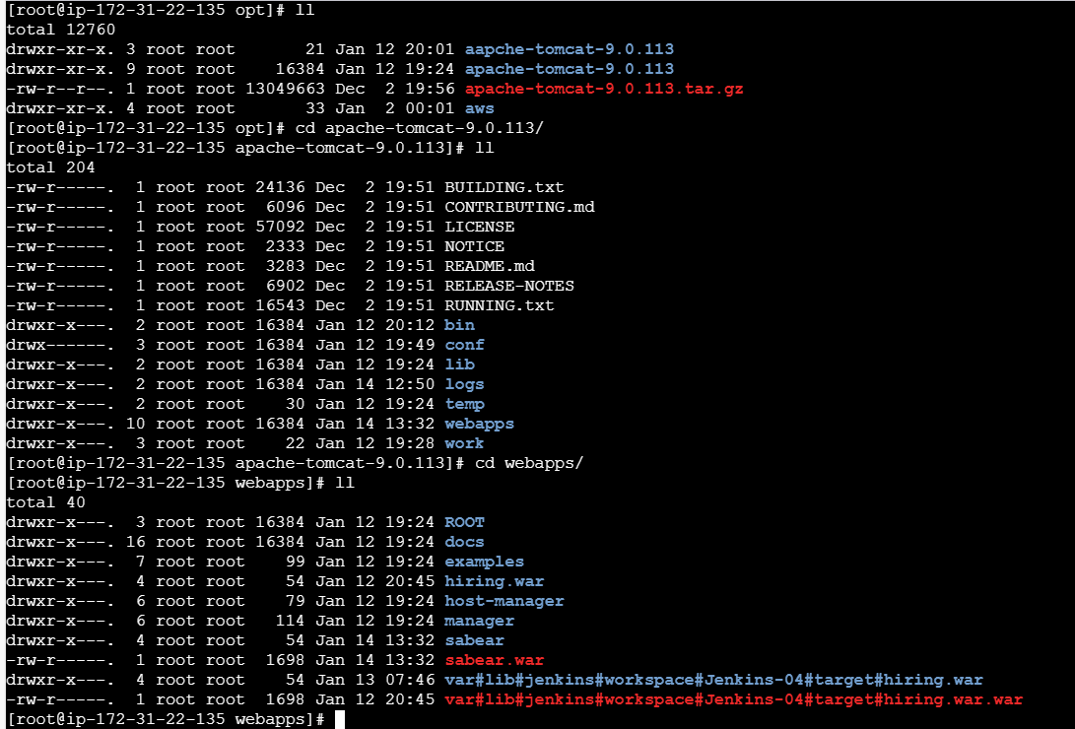

Issues faced:
I added Quality gate to the script after referring to ChatGPT and other documentation from official website. Even after adding 10 minutes of run time, Sonarqube didn’t pull Quality from Jenkins.
So, I removed the Quality gates and ran the script again, then succeeded.

My Declarative Pipeline:

pipeline {
agent any

options {
timestamps()
}

environment {
MAVEN_HOME = '/opt/apache-maven-3.9.12'
PATH = "/opt/apache-maven-3.9.12/bin:${PATH}"

SONAR_PROJECT_KEY = 'Hiring-app'
SONAR_PROJECT_NAME = 'hiringapp'

NEXUS_URL = '100.27.219.147:8081'
NEXUS_REPOSITORY = 'hiring-app'
NEXUS_VERSION = 'nexus3'
NEXUS_PROTOCOL = 'http'

TOMCAT_URL = 'http://3.88.51.237:8080'
}

stages {

stage('Notify Started') {
steps {
slackSend(
color: '#439FE0',
message: "Vicky | ${env.JOB_NAME} - #${env.BUILD_NUMBER} Started (<${env.BUILD_URL}|Open>)",
tokenCredentialId: 'Slack'
)
}
}

stage('Git Clone (Private Repo)') {
steps {
retry(2) {
git branch: 'main',
url: 'https://github.com/betawins/hiring-app.git',
credentialsId: 'github-creds'
}
}
}

stage('Build + SonarQube Analysis') {
steps {
withSonarQubeEnv('sonar-server') {
sh '''
mvn clean verify \
org.sonarsource.scanner.maven:sonar-maven-plugin:sonar \
-Dsonar.projectKey=${SONAR_PROJECT_KEY} \
-Dsonar.projectName=${SONAR_PROJECT_NAME}
'''
}
}
}

stage('Maven Package') {
steps {
sh 'mvn package -DskipTests'
}
}

stage('Nexus Upload') {
steps {
script {
def WAR_FILE = sh(
script: "ls target/*.war | head -n 1",
returnStdout: true
).trim()

nexusArtifactUploader(
nexusVersion: NEXUS_VERSION,
protocol: NEXUS_PROTOCOL,
nexusUrl: NEXUS_URL,
repository: NEXUS_REPOSITORY,
credentialsId: 'nexus_server',
groupId: 'in.javahome',
version: "${env.BUILD_NUMBER}-SNAPSHOT",
artifacts: [[
artifactId: 'hiring',
classifier: '',
type: 'war',
file: WAR_FILE
]]
)
}
}
}

stage('Deploy to Tomcat') {
steps {
deploy adapters: [
tomcat9(
credentialsId: 'tomcat',
url: "${TOMCAT_URL}"
)
],
contextPath: 'sabear',
war: 'target/*.war'
}
}
}

post {
success {
slackSend(
color: 'good',
message: "Vicky | ${env.JOB_NAME} - #${env.BUILD_NUMBER} Success (<${env.BUILD_URL}|Open>)",
tokenCredentialId: 'Slack'
)
}

failure {
slackSend(
color: 'danger',
message: "Vicky | ${env.JOB_NAME} - #${env.BUILD_NUMBER} Failed (<${env.BUILD_URL}|Open>)",
tokenCredentialId: 'Slack'
)
}

always {
cleanWs()
}
}
}

Task- 2 Create one Scripted pipeline job
Objective:
Let’s create a Scripted pipeline groovier and more flexible.

Prerequisites:
Jenkins Setup
- Jenkins server installed and running.
- Required plugins installed:
  - Pipeline plugin (core requirement).
  - Git plugin (for source code checkout).
  - Maven plugin (if building Java projects).
  - SonarQube plugin (for code quality checks).
  - Credentials plugin (for secure access to Git.).
2. Source Code Repository
- Application code stored in GitHub
- A Jenkinsfile created in the repo (written in Declarative syntax).
- Branch strategy defined (e.g., main for production, develop for testing).
3. Build Tools
- Build system installed on Jenkins agent:
Maven for Java.
- Dependencies defined in pom.xml.

4. Credentials & Access
- Jenkins configured with:
  - Git credentials (only a private repo)
  - Artifact repo credentials (Nexus/Artifactory).
  - Deployment credentials (Tomcat Credentials)
5. Environment Setup
- Network access to Git repo, artifact repo, and deployment targets.
- Proper workspace cleanup policy to avoid conflicts.
6. Notification Tools (Optional but Recommended)
- Notification channels (Slack) integrated with Jenkins.

Step by step Implementation:
Step 1: Navigate to Jenkins GUI and create a new job.
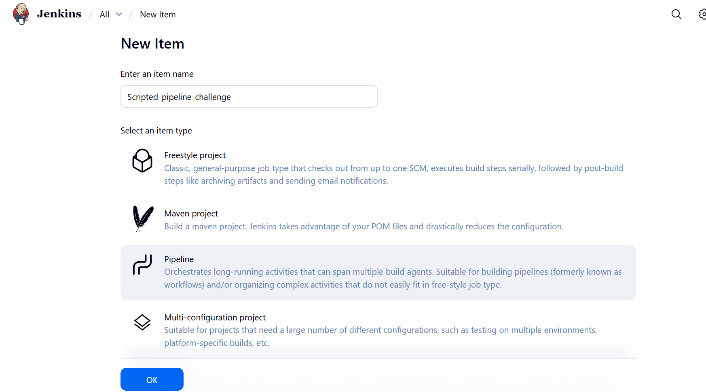
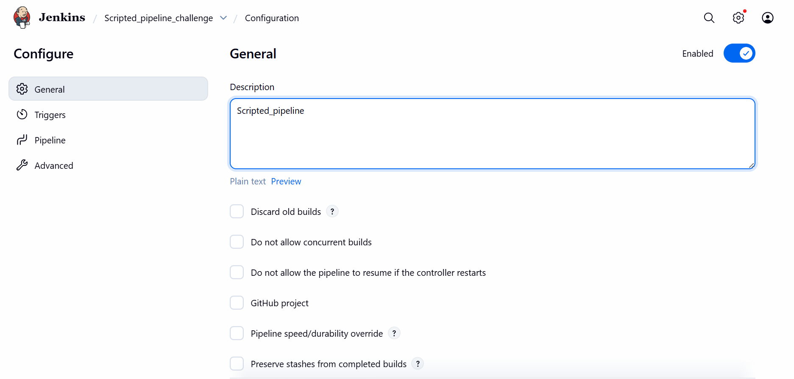

Step 2: Lets create the pipeline and update in the Script section.

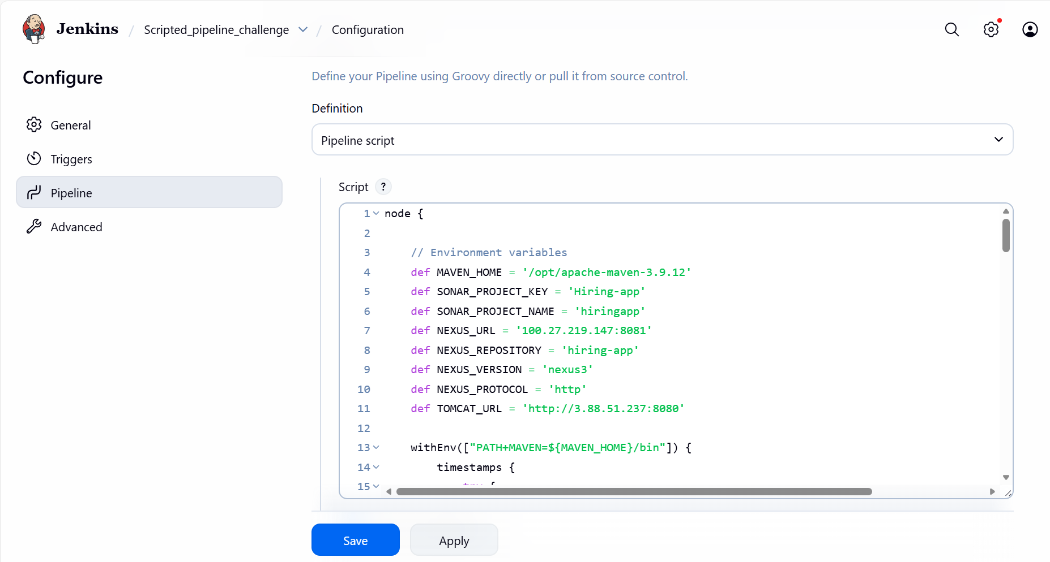
- Pipeline built successfully.
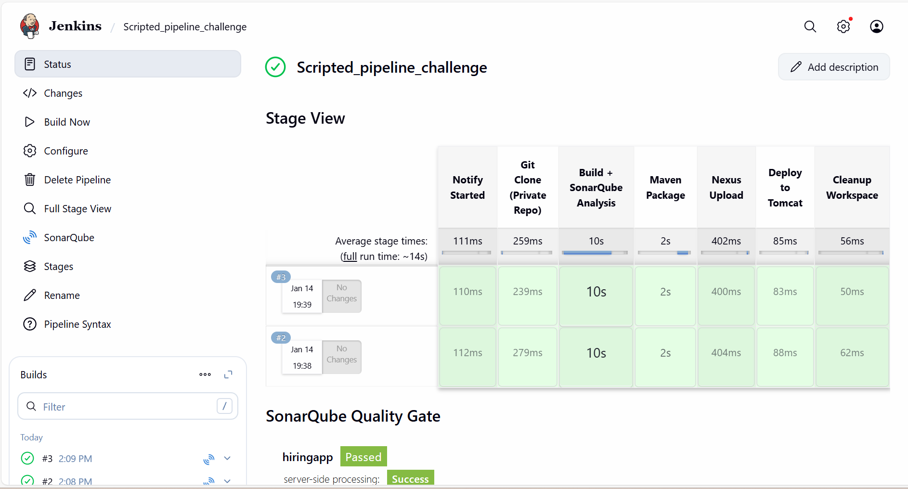

- Console output for reference.
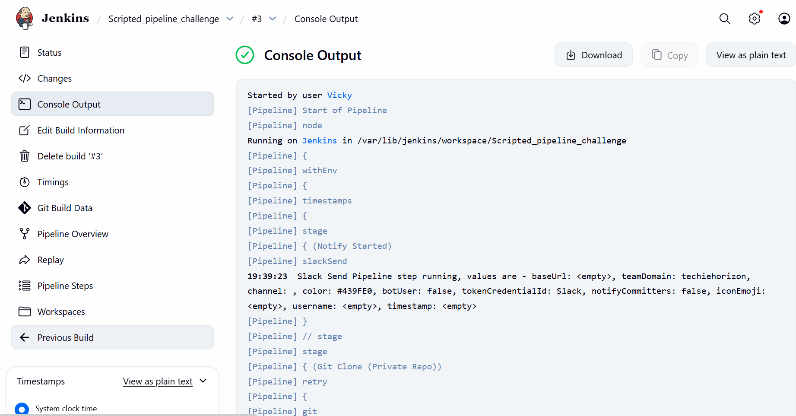

Step 3: Slack Notification
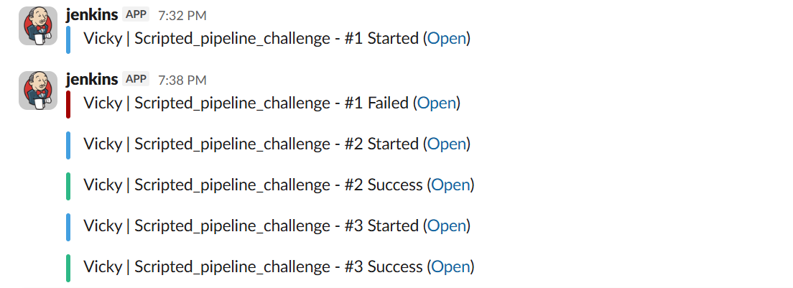

Step 4: Verified the package in browser using command- Tomcat URL:IP/hiring.war
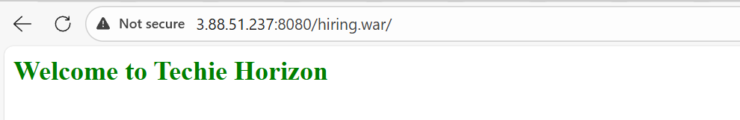

My Scripted Pipeline:

node {

// Environment variables
def MAVEN_HOME = '/opt/apache-maven-3.9.12'
def SONAR_PROJECT_KEY = 'Hiring-app'
def SONAR_PROJECT_NAME = 'hiringapp'
def NEXUS_URL = '100.27.219.147:8081'
def NEXUS_REPOSITORY = 'hiring-app'
def NEXUS_VERSION = 'nexus3'
def NEXUS_PROTOCOL = 'http'
def TOMCAT_URL = 'http://3.88.51.237:8080'

withEnv(["PATH+MAVEN=${MAVEN_HOME}/bin"]) {
timestamps {
try {

stage('Notify Started') {
slackSend(
color: '#439FE0',
message: "Vicky | ${env.JOB_NAME} - #${env.BUILD_NUMBER} Started (<${env.BUILD_URL}|Open>)",
tokenCredentialId: 'Slack'
)
}

stage('Git Clone (Private Repo)') {
retry(2) {
git branch: 'main',
url: 'https://github.com/betawins/hiring-app.git',
credentialsId: 'github-creds'
}
}

stage('Build + SonarQube Analysis') {
withSonarQubeEnv('sonar-server') {
sh """
mvn clean verify \
org.sonarsource.scanner.maven:sonar-maven-plugin:sonar \
-Dsonar.projectKey=${SONAR_PROJECT_KEY} \
-Dsonar.projectName=${SONAR_PROJECT_NAME}
"""
}
}

stage('Maven Package') {
sh 'mvn package -DskipTests'
}

stage('Nexus Upload') {
def WAR_FILE = sh(
script: "ls target/*.war | head -n 1",
returnStdout: true
).trim()

nexusArtifactUploader(
nexusVersion: NEXUS_VERSION,
protocol: NEXUS_PROTOCOL,
nexusUrl: NEXUS_URL,
repository: NEXUS_REPOSITORY,
credentialsId: 'nexus_server',
groupId: 'in.javahome',
version: "${env.BUILD_NUMBER}-SNAPSHOT",
artifacts: [[
artifactId: 'hiring',
classifier: '',
type: 'war',
file: WAR_FILE
]]
)
}

stage('Deploy to Tomcat') {
deploy adapters: [
tomcat9(
credentialsId: 'tomcat',
url: "${TOMCAT_URL}"
)
],
contextPath: 'sabear',
war: 'target/*.war'
}

// Success Notification
slackSend(
color: 'good',
message: "Vicky | ${env.JOB_NAME} - #${env.BUILD_NUMBER} Success (<${env.BUILD_URL}|Open>)",
tokenCredentialId: 'Slack'
)

} catch (Exception e) {

// Failure Notification
slackSend(
color: 'danger',
message: "Vicky | ${env.JOB_NAME} - #${env.BUILD_NUMBER} Failed (<${env.BUILD_URL}|Open>)",
tokenCredentialId: 'Slack'
)

throw e

} finally {

stage('Cleanup Workspace') {
cleanWs()
}
}
}
}
}
Task 3: Create one multi stage pipeline job
What is a Multi-Stage Scripted Pipeline?
A Scripted Pipeline is the original way to write Jenkins pipelines using Groovy. It provides maximum flexibility, allowing you to use complex logic and loops. By dividing it into Stages, you create a "multi-stage" workflow where each part of the process (Clone, Build, Test, Deploy) is clearly separated for better monitoring and error tracking.

Objective:
To automate the end-to-end delivery of the "Hiring App" by integrating code scanning, artifact archiving in a Nexus MIXED repository, and automated deployment to a Tomcat 9 server.

Prerequisites:
Before running this pipeline, ensure your environment is configured correctly:
- Hardware: An EC2 instance (e.g., m7i.flex) with at least 8GB of RAM for Nexus.
Java Environment: Ensure Java 17 is the active version; Nexus 3 will shut down if Java 21 is detected.
- Jenkins Credentials:
  - nexus_server: Must be Username with password type (not "Secret text").
  - tomcat: Username/Password for the Tomcat manager.
  - slack_notification: Secret text for API access.

Difference between declarative and multistage pipeline
Feature | Declarative (Descriptive) | Scripted (Multi-Stage Capable)
Learning Curve | Low; very intuitive for beginners. | High; requires Groovy programming knowledge.
Flexibility | Limited by a pre-defined structure. | Unlimited; can handle any complex logic.
Syntax Validation | Validated before execution begins. | Fails only when it hits the error during runtime.
Error Handling | Simple, intuitive mechanisms. | Granular and powerful using try-catch.

Step by step Implementation:
Step 1: Navigate to Jenkins GUI and create a new job- Multi-stage scripted pipeline
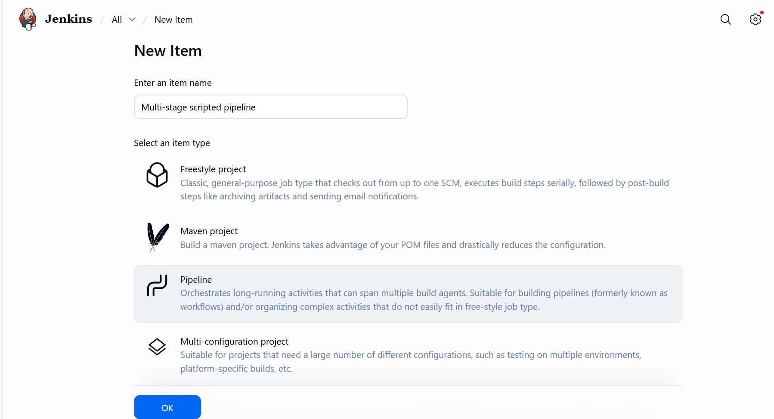

Step 2: Created script for my Multi-stage scripted pipeline and updated in Script.
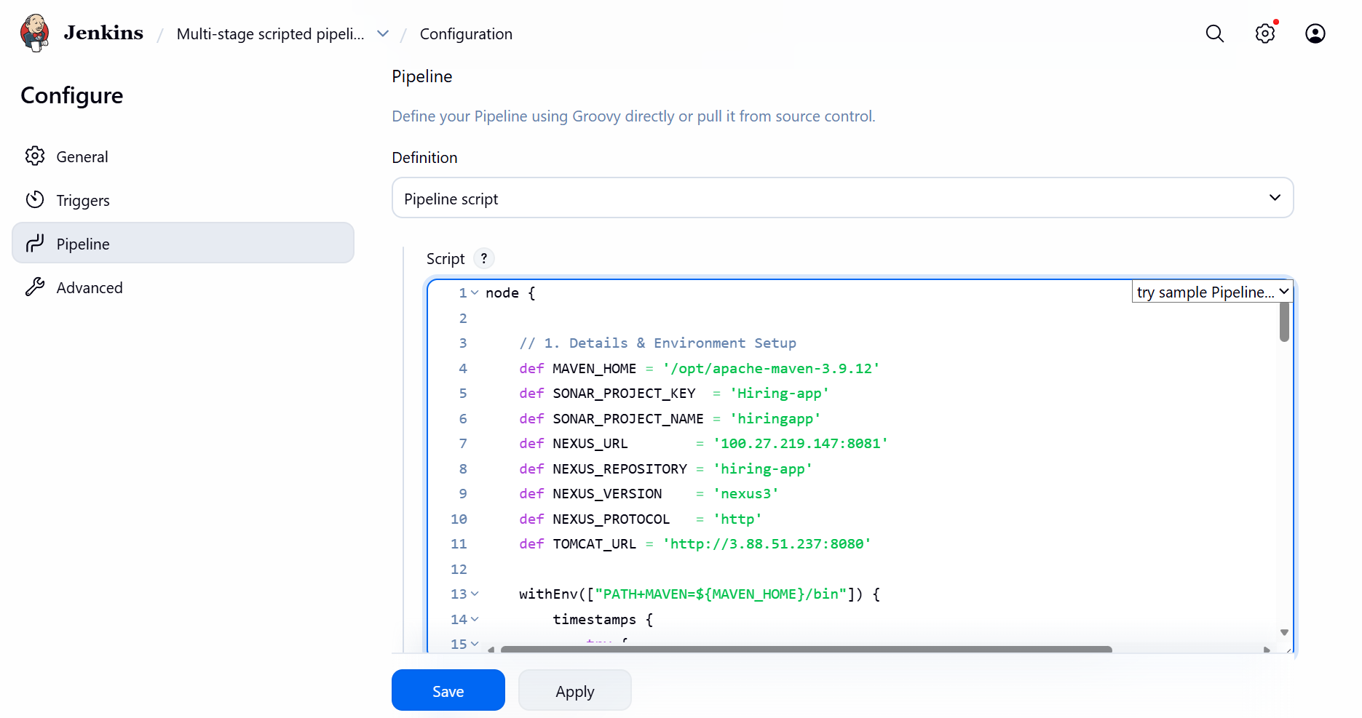
Step 3: Once updated the script, executed via Build now.
Success
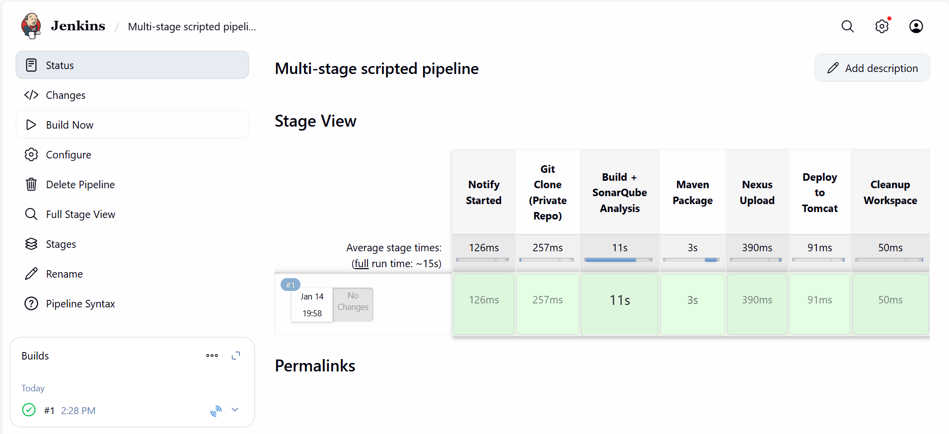

Step 4: Reviewed console output and its always recommended to verify the console output to see if there were any warnings.
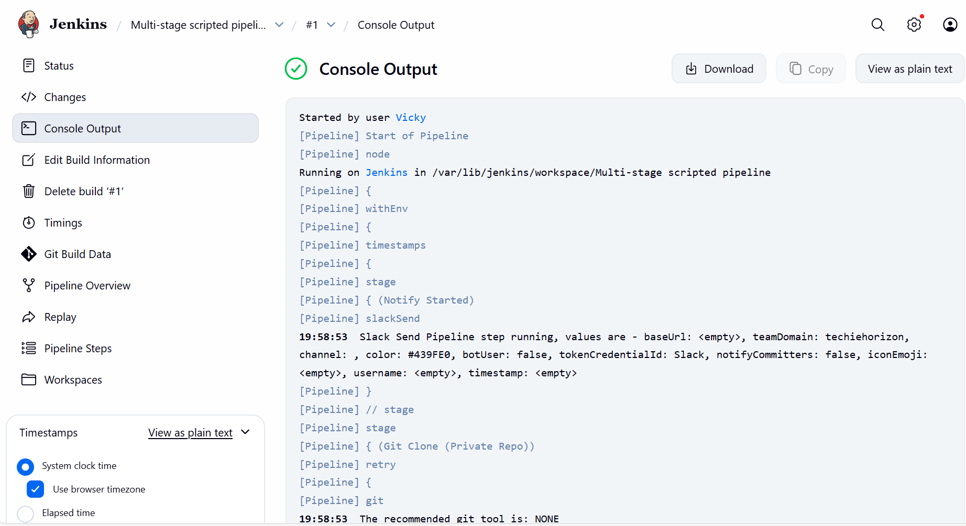

Step 5: Slack notification
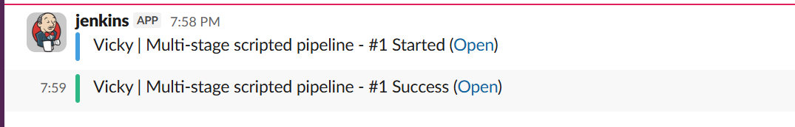

Step 6: Verified if package is deployed to Tomcat.
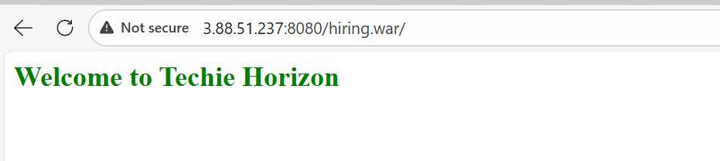

Conclusion:
If you want an easy-to-manage process that your whole team can understand, use a Declarative Pipeline with multiple stages. If your process is highly complex and requires custom programming logic that standard stages can't handle, use a Scripted Pipeline.

Task 4: Create one parallel stage pipeline job
What is a Parallel Pipeline?
In a parallel pipeline, stages that do not depend on each other are executed at the same time on the same node or different agents. For your project, since SonarQube just reads the code and Maven packages it, they can run together to save time.
Objective:
To decrease delivery lead time by executing the Quality Analysis and the Packaging stages in parallel, while maintaining the end-to-end flow from Git to Tomcat.
Prerequisites
- Hardware: An EC2 instance (m7i.flex) with 8GB RAM to support concurrent Java processes.
- Java: Version 11 must be active for Nexus compatibility.
- Credentials: nexus_server must be Username with password type.

Step by step Implementation:
Step 1: Navigate to Jenkins GUI and create a new job- Parallel job.
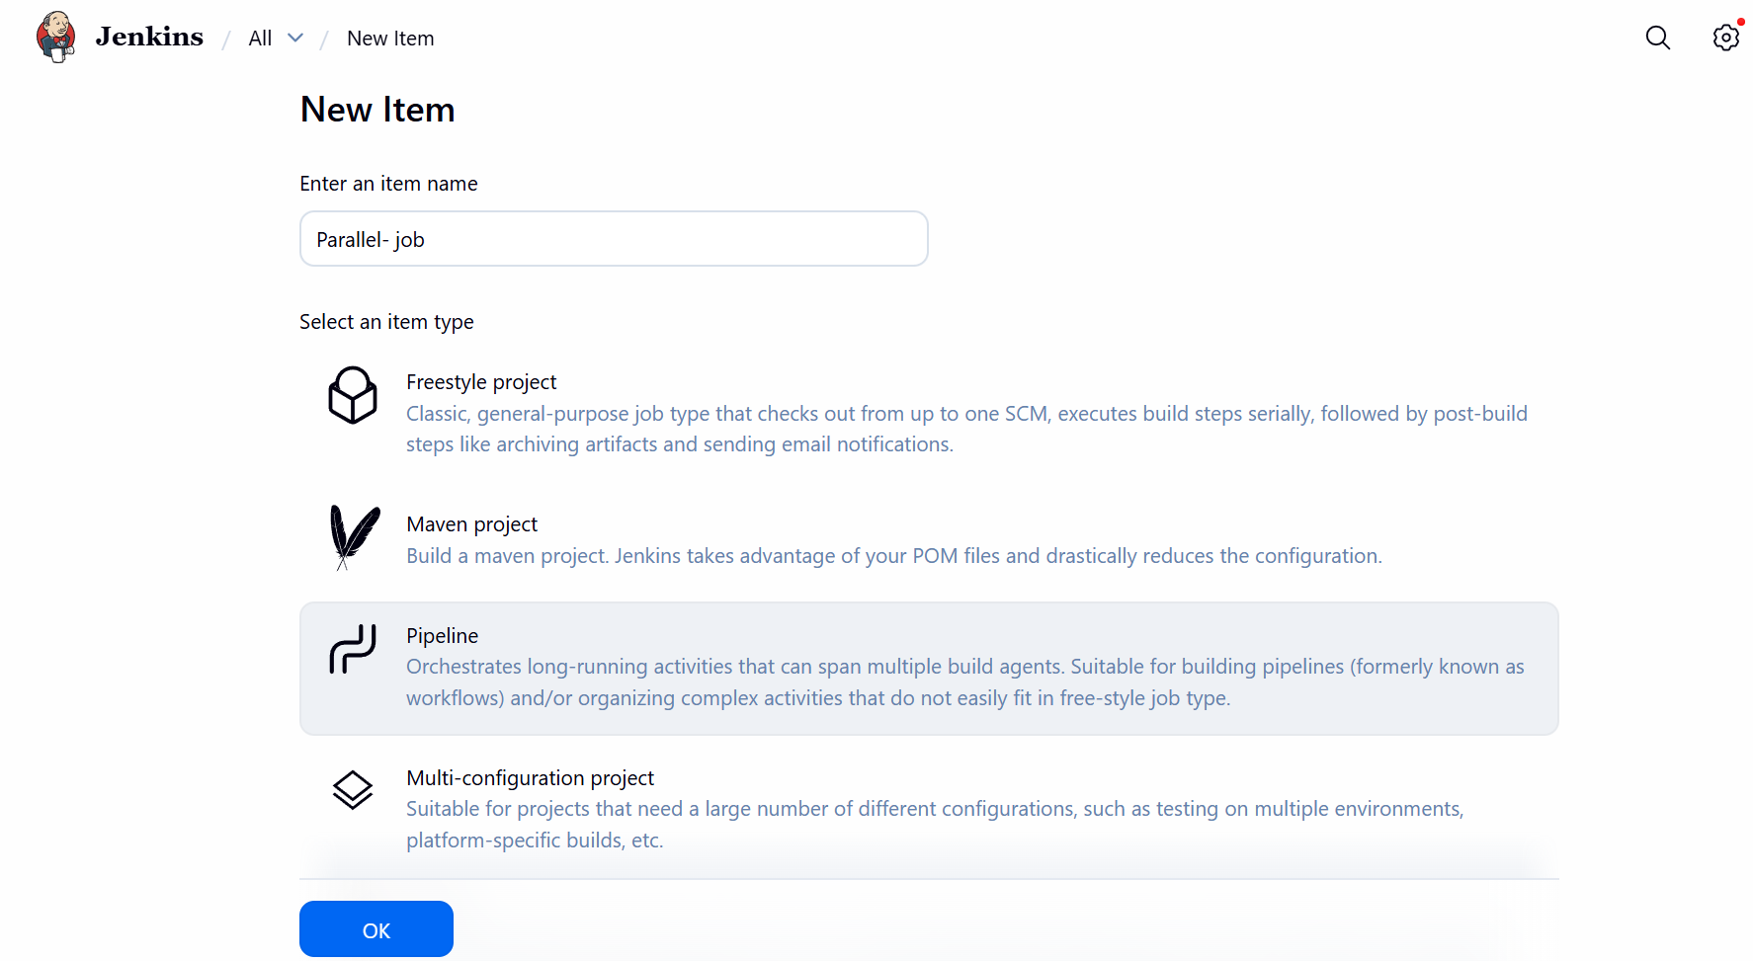

Step 2: Configure the job with adding a script to the script section.
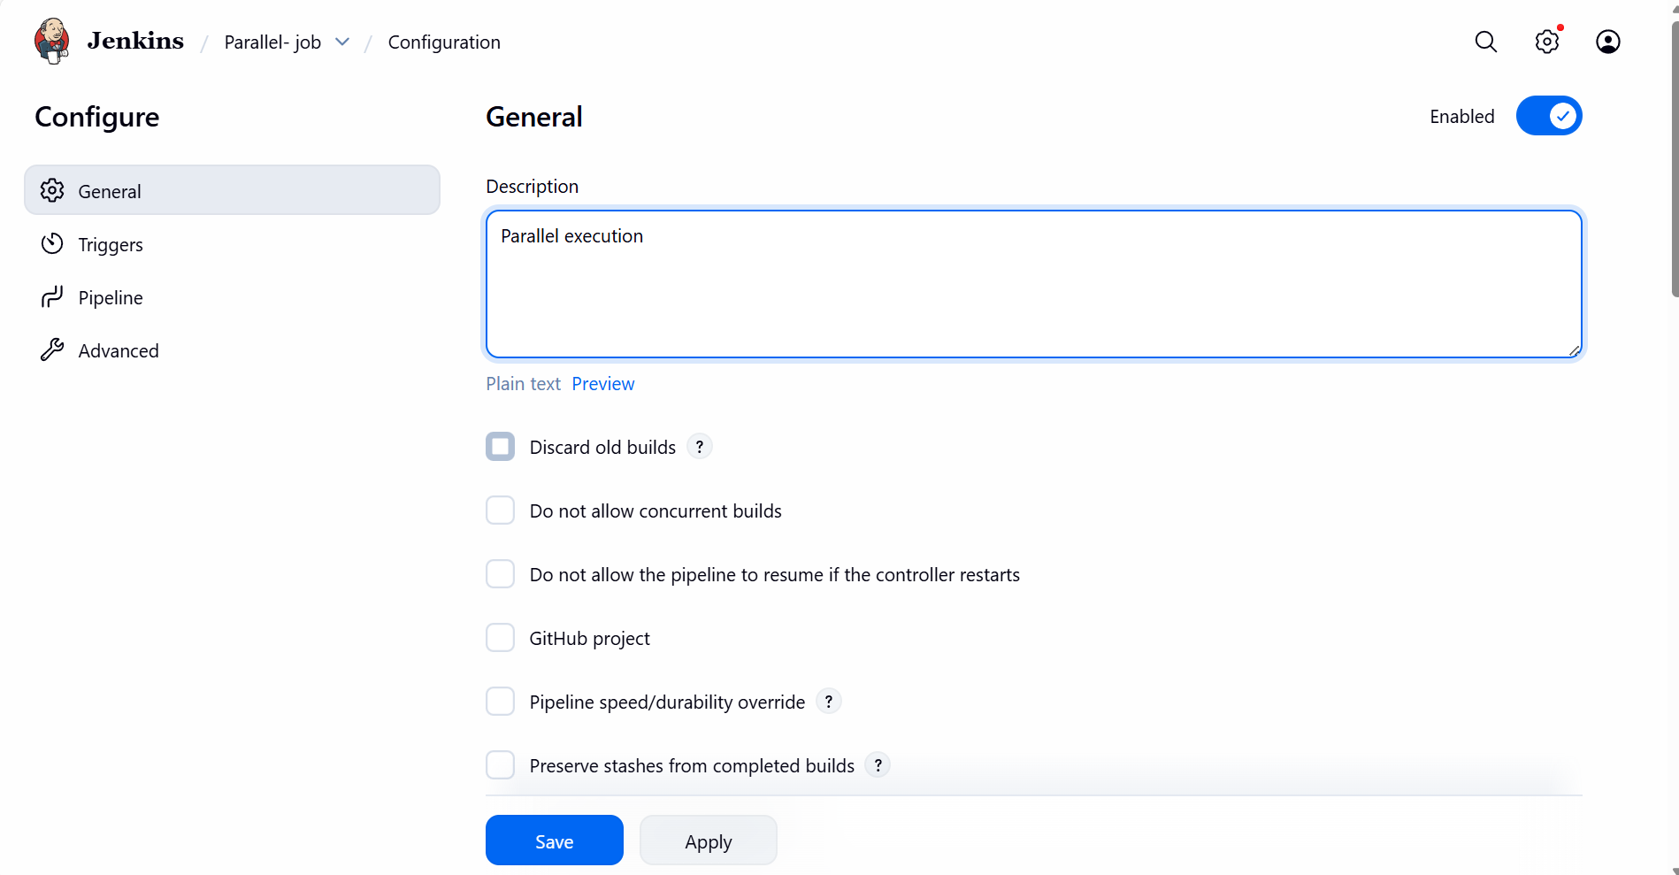
- Updated the script
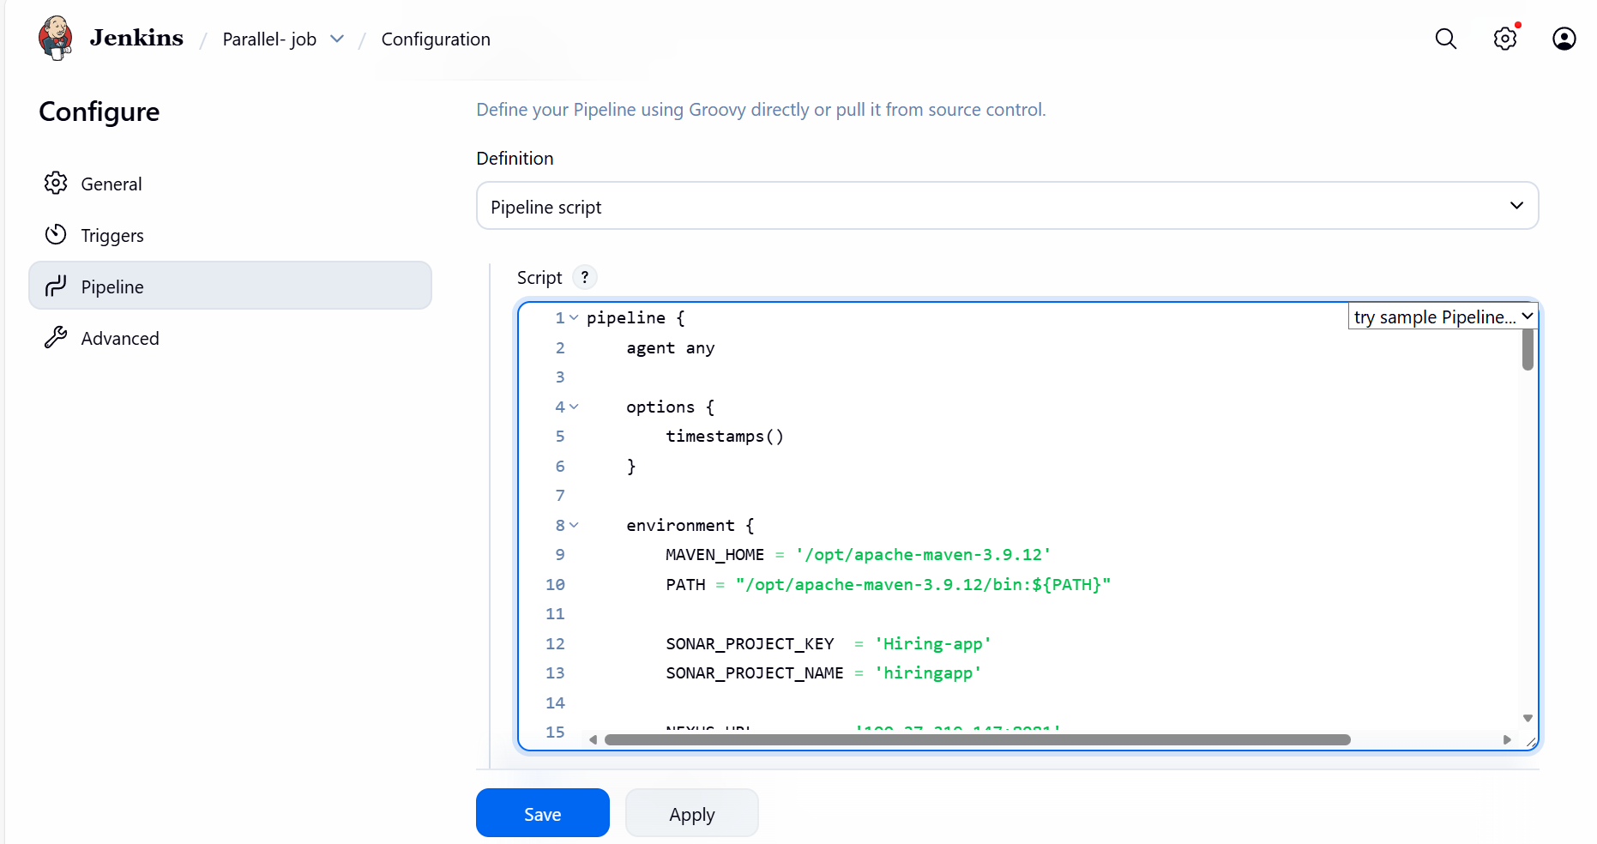

Step 4: Build Now and verify if the script runs as expected.
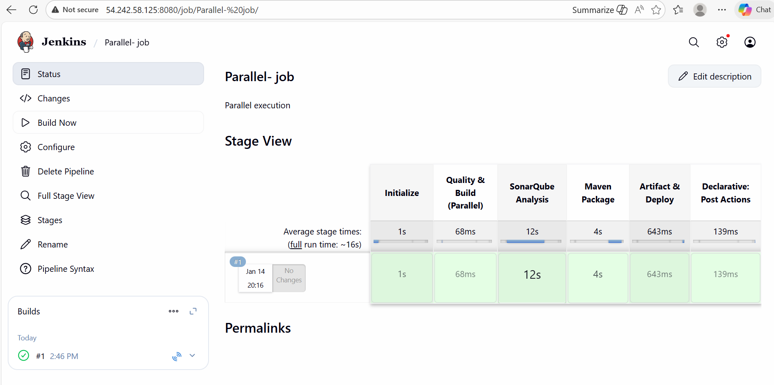

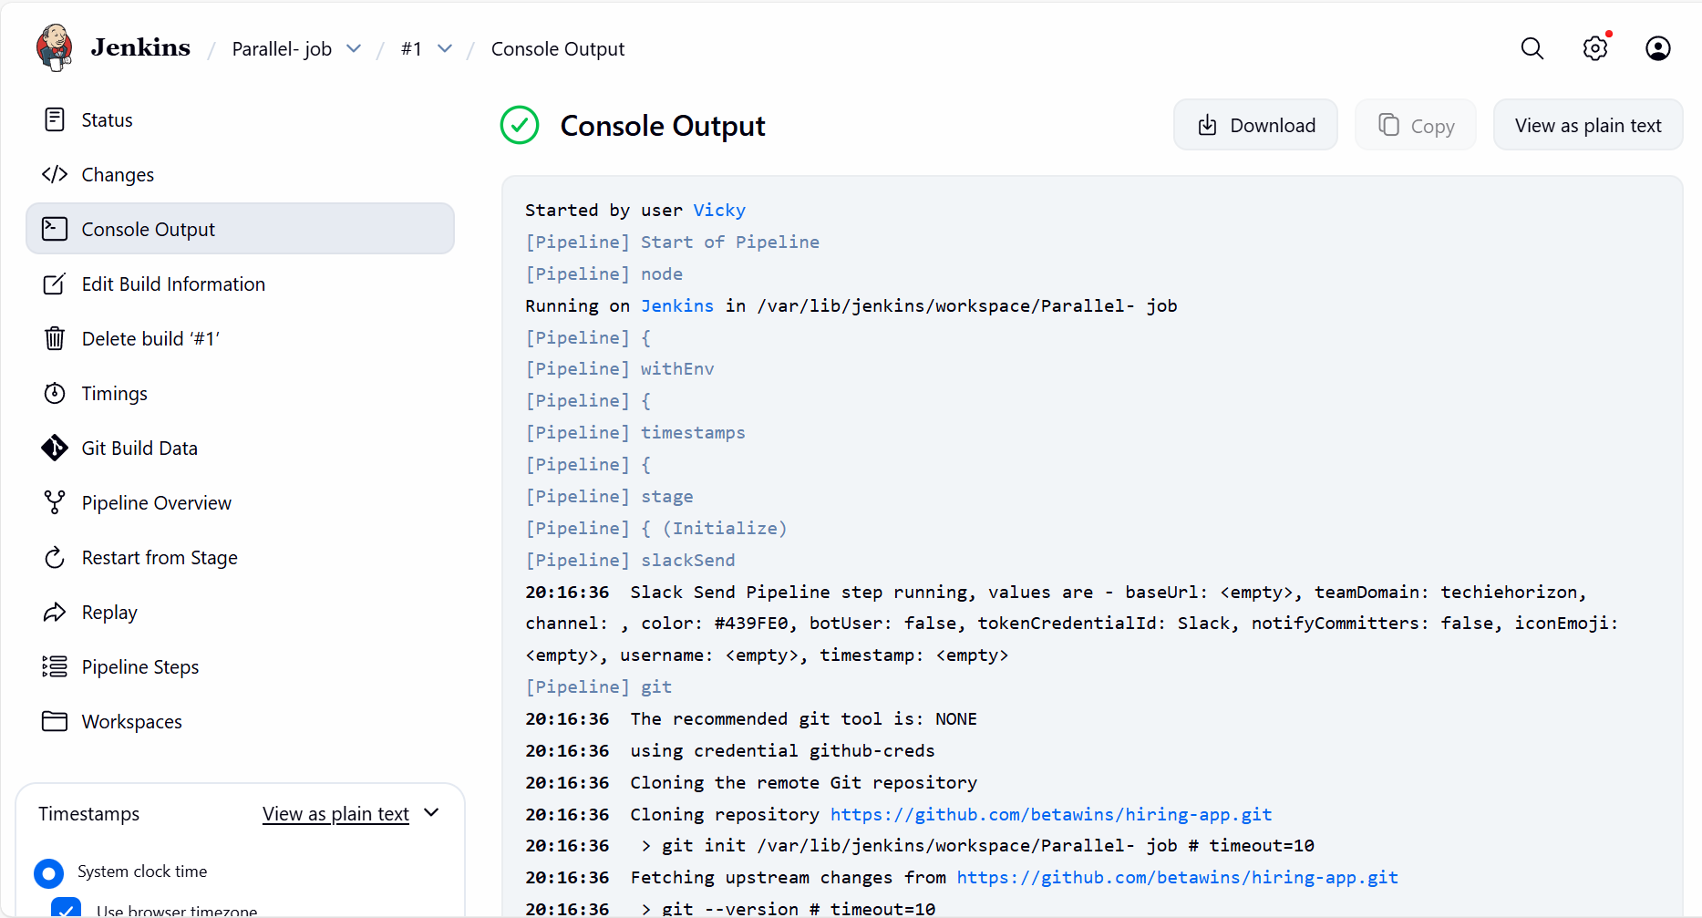

Step 5: Slack Notification verified.
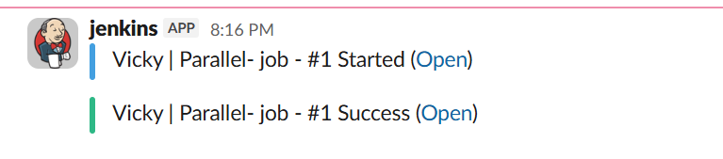
Step 6: Verified the package is deployed to Tomcat.
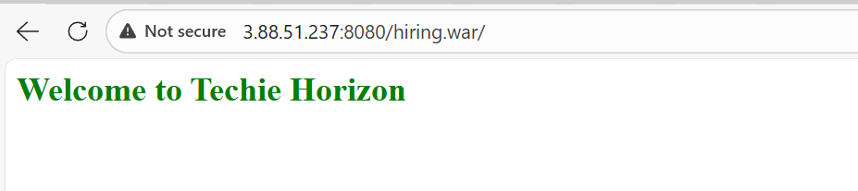

My parallel-stage pipeline script:

pipeline {
agent any

options {
timestamps()
}

environment {
MAVEN_HOME = '/opt/apache-maven-3.9.12'
PATH = "/opt/apache-maven-3.9.12/bin:${PATH}"

SONAR_PROJECT_KEY = 'Hiring-app'
SONAR_PROJECT_NAME = 'hiringapp'

NEXUS_URL = '100.27.219.147:8081'
NEXUS_REPOSITORY = 'hiring-app'
NEXUS_VERSION = 'nexus3'
NEXUS_PROTOCOL = 'http'

TOMCAT_URL = 'http://3.88.51.237:8080'
}

stages {

stage('Initialize') {
steps {
slackSend(
color: '#439FE0',
message: "Vicky | ${env.JOB_NAME} - #${env.BUILD_NUMBER} Started (<${env.BUILD_URL}|Open>)",
tokenCredentialId: 'Slack'
)

git branch: 'main',
url: 'https://github.com/betawins/hiring-app.git',
credentialsId: 'github-creds'
}
}

stage('Quality & Build (Parallel)') {
parallel {

stage('SonarQube Analysis') {
steps {
withSonarQubeEnv('sonar-server') {
sh '''
mvn clean verify \
org.sonarsource.scanner.maven:sonar-maven-plugin:sonar \
-Dsonar.projectKey=${SONAR_PROJECT_KEY} \
-Dsonar.projectName=${SONAR_PROJECT_NAME}
'''
}
}
}

stage('Maven Package') {
steps {
sh 'mvn clean package -DskipTests'
}
}
}
}

stage('Artifact & Deploy') {
steps {
script {
def WAR_FILE = sh(
script: "ls target/*.war | head -n 1",
returnStdout: true
).trim()

nexusArtifactUploader(
nexusVersion: NEXUS_VERSION,
protocol: NEXUS_PROTOCOL,
nexusUrl: NEXUS_URL,
repository: NEXUS_REPOSITORY,
credentialsId: 'nexus_server',
groupId: 'in.javahome',
version: "${env.BUILD_NUMBER}-SNAPSHOT",
artifacts: [[
artifactId: 'hiring',
classifier: '',
type: 'war',
file: WAR_FILE
]]
)

deploy adapters: [
tomcat9(
credentialsId: 'tomcat',
url: "${TOMCAT_URL}"
)
],
contextPath: 'sabear',
war: WAR_FILE
}
}
}
}

post {
success {
slackSend(
color: 'good',
message: "Vicky | ${env.JOB_NAME} - #${env.BUILD_NUMBER} Success (<${env.BUILD_URL}|Open>)",
tokenCredentialId: 'Slack'
)
}

failure {
slackSend(
color: 'danger',
message: "Vicky | ${env.JOB_NAME} - #${env.BUILD_NUMBER} Failed (<${env.BUILD_URL}|Open>)",
tokenCredentialId: 'Slack'
)
}

always {
cleanWs()
}
}
}

